**How to Update the Firmware**

**Hardware** is the physical part of a micro:bit.

**Software** is made up of the programs you write and run on your micro:bit.

**Firmware** is in the middle: a special kind of software that makes devices function properly. It’s physically stored in the micro:bit’s interface chip and doesn’t change when you write programs or turn your micro:bit off, but it can be updated.

The micro:bit will work with the firmware it came with, but there may be times when you may want to update the firmware to use new features like [WebUSB](https://microbit.org/get-started/user-guide/web-usb/).

### Checking your firmware version

To find out what version of the firmware you have on your micro:bit, **Plug it in via USB**, open up the **DETAILS.TXT** file from the **MICROBIT** drive and look for the number on the line that begins 'Interface Version'. In this example, the firmware version is 0250:

# DAPLink Firmware - see https://mbed.com/daplink Unique ID: 9900000031634e4500624014000000320000000097969901  
HIC ID: 97969901  
Auto Reset: 1  
Automation allowed: 0  
Overflow detection: 0  
Daplink Mode: Interface  
**Interface Version: 0250**Git SHA: 682d8303e37355532402b8d93c4f240a3cec02a9  
Local Mods: 0  
USB Interfaces: MSD, CDC, HID, WebUSB  
Interface CRC: 0x3f2b7e12  
Remount count: 0URL: https://microbit.org/device/?id=9900&v=0250

### How to update the firmware

Disconnect the USB cable and battery pack from the micro:bit.

Hold the reset button at the back of the micro:bit and plug the USB lead into the device. You should see a drive appear in your file manager called **MAINTENANCE** (instead of MICROBIT).

# IMG_256

The **MAINTENANCE** drive will look like this, depending on your computer:

### Windows

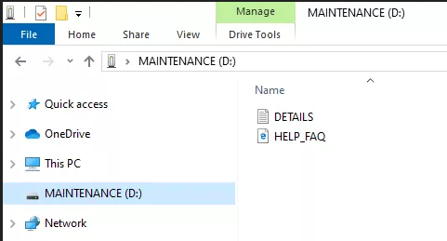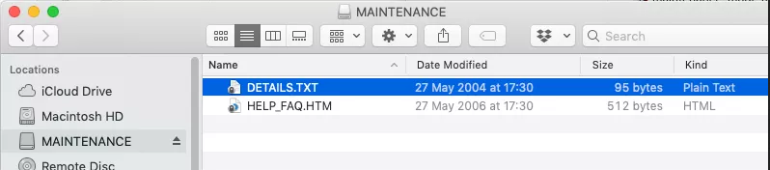

* Download the hex file from this page to your computer.

[Downlaod the latest firmware-0253](https://cdn.sanity.io/files/ajwvhvgo/production/5ecfa4d407a9d02e0f2e7fe192e5fa6a246f8621.hex?dl=0253_kl26z_microbit_0x8000.hex )

* Drag and drop the new firmware .HEX file you downloaded from this page onto the **MAINTENANCE** drive and wait for the yellow LED on the back of the device to stop flashing. When the upgrade is completed, the micro:bit will reset, ejecting itself from the computer and re-appear in normal **MICROBIT** drive mode.
* Finally, check the **DETAILS.TXT** file that is on the **MICROBIT** drive and make sure that it has the same version number as the .HEX firmware that you just downloaded and flashed to the interface chip.